**Computer Programming (C20013) Examination**

### Date: 09/04/2013 - Allowed Time: 2 Hours

Procedure:

There are 4 questions. Answer only 3 questions. Answer all parts of these 3 questions.

Each question carries 40 marks. There are a total of 120 marks available.

***100% from this exam will contribute 40% towards your final grade.***

***Note:*** The use of any kind of electronic equipment is not permitted during the exam. Write your answers on A4 Paper (plain or with lines). Ensure all of your work is submitted to the teacher at the end of the examination. Write your name on every A4 page you use. Examination attendance must be signed to receive a grade.

### Question 1 (40 marks)

1. List three data types in C and describe when it is appropriate to use each.
2. Explain the syntax and semantics of an “if” statement in C.
3. Explain the syntax and semantics of an assignment “=” statement.
4. Write C code that adds two hard-coded numbers together. Print out “Sum is greater than 10” if the sum is greater than 10.
5. Write C code that takes an integer grade from the user. The program should print “Distinction” for a grade from 80 to 100, “Merit” for a grade from 65 to 79, “Pass” for a grade from 50 to 64, and “Invalid grade” for all other grades. This should be done with the use of an “if” statement, with “if else”, and “else”.
6. List and describe three logical operators in C. Provide an example of how each logical operator works.
7. What is the difference between a compiler and an interpreter?
8. Write C code that uses a nested for loop to draw the graphical shape of a right-angled triangle of asterisks like so:



### Question 2 (40 marks)

1. What is a program?
2. What is a programming language?
3. Describe two different generations of programming languages with languages. Include a language that belong to each generation in your answer.
4. What are the relative advantages and disadvantages of each of the two language generations you described in the previous question?
5. List the stages in the construction a loop.
6. Explain the syntax and semantics of a “while” statement
7. Explain the syntax and semantics of a “for” loop in C.
8. What is an array?
9. With the use of an example, explain why is the array data structure is necessary?
10. What is the difference between the value of an array element and its corresponding index? Include a relevant diagram.
11. Write C code that populates an integer array with 5 numbers (hard-coded) and searches the array for a certain (hard-coded) number.
12. Write C code that populates an integer array with 5 numbers (hard-coded) and print out the sum of the values in the array using:
    1. a “while” loop.
    2. a “for” loop.

### Question 3 (40 marks)

1. What is the difference between system software and application software? Include three examples of each.
2. What is a sentinel? Include C code with a while loop and a sentinel to better explain a sentinel.
3. What is top-down development?
4. Use the top-down development technique to describe an approach to programming an ATM.
5. List three uses of an editor for software development?
6. Explain how to perform the following editor operations:
   1. Find and replace
   2. Block copy
   3. Block insertion
   4. Block deletion
7. Explain, with examples, the following programming constructs:
   1. Input/Ouput
   2. Cursor and screen handling
8. Explain what a variable is
9. What does ASCII stand for?
10. What is the ASCII table?
11. List the relational operators for the character data type in C and describe how the ASCII table is relevant to the relational operators.
12. What are control characters?
13. List three control characters and describe what each does.
14. Justify the statement: the ASCII table is an ordinal set of values.
15. What is the role of the extended ASCII set?
16. What is a string? How is a string represented in C?
17. Write C code to create and print a string.

### Question 4 (40 marks)

1. Define a procedure.
2. Explain the need for procedures.
3. Write down the standard syntax for a procedure definition in C.
4. Write a C procedure without parameters to print “Hello”.
5. What does it mean if a variable has function scope?
6. What does it mean if a variable has block scope? Give an example of a variable with block scope.
7. Identify the scope of each variable in the following program:

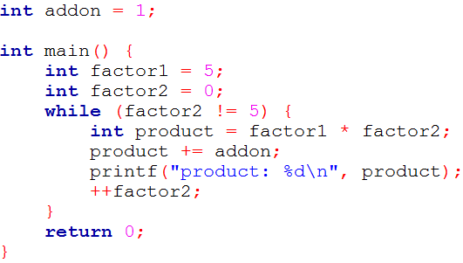

1. What is a function?
2. What is the difference between user defined functions and standard library functions?
3. Explain the difference between a function and a procedure.
4. Define the length of a string.
5. What is the difference between the length of a string and its dimension?
6. Write C code to that creates a string a uses a “for” loop to calculate the length of the string.
7. Why is data validation needed?
8. What do the following boolean expressions evaluate to:
   1. true AND NOT true
   2. (true AND false) OR true
   3. (false OR NOT false) AND true